* <https://docs.microsoft.com/en-us/azure/api-management/api-management-key-concepts>
* 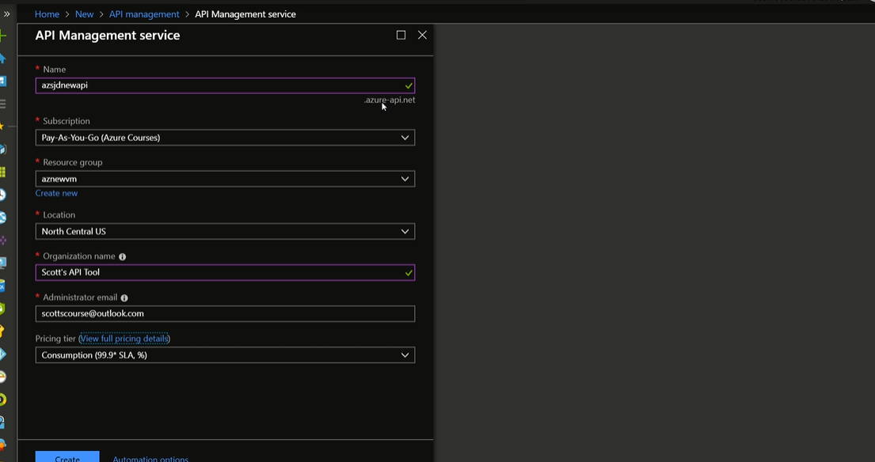

Backend for API Management Service.

* We can add product in the API at Partner level.
* We set up the api with an logic app and give its access to general or partner level.
* Then we use API management link to make calls to the api.
* Logic app can become the endpoint to the API Management service.